Wireshark - TCP

In this project, we’ll investigate the behavior of the celebrated TCP protocol in detail. We’ll do so by analyzing a trace of the TCP segments sent and received in transferring a 150KB file (containing the text of Lewis Carrol’s Alice’s Adventures in Wonderland) from your computer to a remote server

Before beginning this lab, you’ll probably want to review sections 3.5 and 3.7 in the textbook.

Remarks:
- I prepared a video that shows how to capture packets and answer the questions. https://drive.google.com/open?id=1ptObl70dVFbUURzVGFuW8ZKeAHoJxbnv
- On Windows Operating Systems, you need to run Wireshark as administrator so that it can access your network interface card.

Preliminary Steps:
- Disable IPv6, if applicable.
- Disable Large Send Offload (also called, TCP Segmentation Offload), if possible. (You may have this if you use a desktop computer with a wired Ethernet cable. You may not need to worry about this if you have a laptop on WiFi.)

Capture your own packets and answer the questions based on your captured packets. Include screenshots whenever possible immediately after the corresponding questions and answers; annotate/highlight the information that your answers are based on. You will lose (many) points if you do not provide necessary screenshots.

1. Capturing a bulk TCP transfer from your computer to a remote server

Before beginning our exploration of TCP, we’ll need to use Wireshark to obtain a packet trace of the TCP transfer of a file from your computer to a remote server. You’ll do so by accessing a Web page that will allow you to enter the name of a file stored on your computer (which contains the ASCII text of Alice in Wonderland), and then transfer the file to a Web server using the HTTP POST method (see section 2.2.3 in the text). We’re using the POST method rather than the GET method as we’d like to transfer a large amount of data from your computer to another computer. Of course, we’ll be running Wireshark during this time to obtain the trace of the TCP segments sent and received from your computer.

Do the following:
- Start up your web browser. Go to http://gaia.cs.umass.edu/wireshark-labs/alice.txt and retrieve an ASCII copy of Alice in Wonderland. Store this file somewhere on your computer.
- Next go to http://gaia.cs.umass.edu/wireshark-labs/TCP-wireshark-file1.html.
- You should see a screen that looks like:

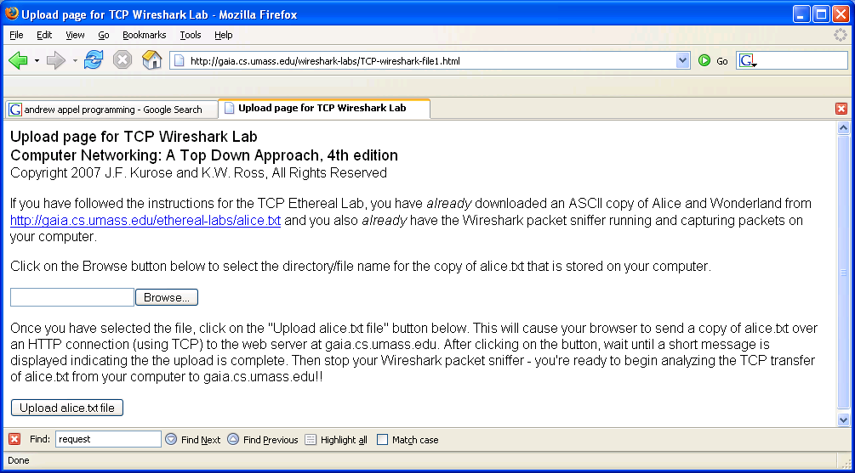

- Use the Browse button in this form to enter the name of the file (full path name) on your computer containing Alice in Wonderland (or do so manually). Don’t yet press the “Upload alice.txt file” button.
- Now start up Wireshark and begin packet capture (Capture->Start) and then press OK on the Wireshark Packet Capture Options screen (we’ll not need to select any options here).
- Returning to your browser, press the “Upload alice.txt file” button to upload the file to the gaia.cs.umass.edu server. Once the file has been uploaded, a short congratulations message will be displayed in your browser window.
- Stop Wireshark packet capture. Your Wireshark window should look similar to the window shown below.

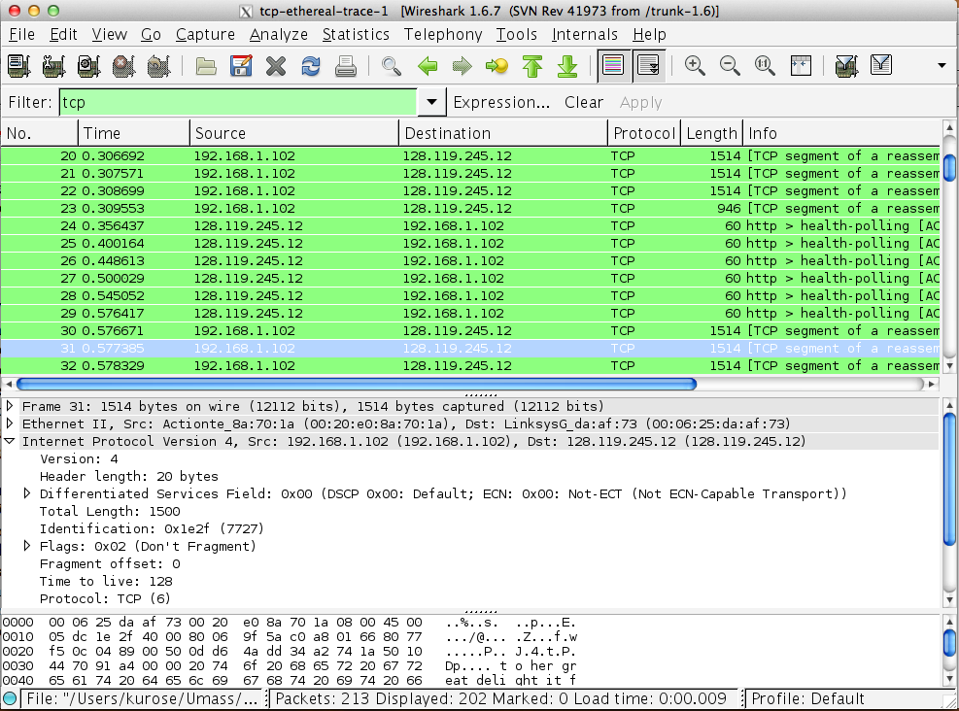

2. A first look at the captured trace

Before analyzing the behavior of the TCP connection in detail, let’s take a high level view of the trace.
- First, filter the packets displayed in the Wireshark window by entering “tcp” (lowercase, no quotes, and don’t forget to press return after entering!) into the display filter specification window towards the top of the Wireshark window.

What you should see is series of TCP and HTTP messages between your computer and gaia.cs.umass.edu. You should see the initial three-way handshake containing a SYN message. You should see an HTTP POST message. Depending on the version of Wireshark you are using, you might see a series of “HTTP Continuation” messages being sent from your computer to gaia.cs.umass.edu. Recall from our discussion in the earlier HTTP Wireshark lab, that is no such thing as an HTTP Continuation message – this is Wireshark’s way of indicating that there are multiple TCP segments being used to carry a single HTTP message. In more recent versions of Wireshark, you’ll see “[TCP segment of a reassembled PDU]” in the Info column of the Wireshark display to indicate that this TCP segment contained data that belonged to an upper layer protocol message (in our case here, HTTP). You should also see TCP ACK segments being returned from gaia.cs.umass.edu to your computer.

Answer the following questions according to your captured packets.
- What is the IP address and TCP port number used by the client computer (source) that is transferring the file to gaia.cs.umass.edu? To answer this question, it’s probably easiest to select an HTTP message and explore the details of the TCP packet used to carry this HTTP message, using the “details of the selected packet header window” (refer to Figure 2 in the “Getting Started with Wireshark” Lab if you’re uncertain about the Wireshark windows.
- What is the IP address of gaia.cs.umass.edu? On what port number is it sending and receiving TCP segments for this connection?

We will use the packet trace that you have captured to study TCP behavior in the rest of this lab.

3. TCP Basics

Answer the following questions for the TCP segments:

- What is the sequence number of the TCP SYN segment that is used to initiate the TCP connection between the client computer and gaia.cs.umass.edu? What is it in the segment that identifies the segment as a SYN segment?
- What is the sequence number of the SYNACK segment sent by gaia.cs.umass.edu to the client computer in reply to the SYN? What is the value of the Acknowledgement field in the SYNACK segment? How did gaia.cs.umass.edu determine that value? What is it in the segment that identifies the segment as a SYNACK segment?
- What is the sequence number of the TCP segment containing the HTTP POST command? Note that in order to find the POST command, you’ll need to dig into the packet content field at the bottom of the Wireshark window, looking for a segment with a “POST” within its DATA field.
- Consider the TCP segment containing the HTTP POST as the first segment in the TCP connection. What are the sequence numbers of the first six segments in the TCP connection (including the segment containing the HTTP POST)? At what time was each segment sent? Select an arbitrary ACK segment (which is for a TCP data segment sent by your client to the server) sent back by the web server; when was it received? When was the corresponding TCP data segment sent? Please calculate the RTT (Round Trip Time) for the corresponding TCP data segment and its ACK.
- What is the length of each of the first six TCP segments? Based on this information, what’s the MSS (Maximum Segment Size)?
- What is the minimum amount of available buffer space advertised at the receiver for the entire trace?
- Are there any retransmitted segments in the trace file? What did you check for (in the trace) in order to answer this question?
- How much data does the receiver typically acknowledge in an ACK? Providing the information for one ACK is enough. You need to first pick the ACK, and then find the corresponding TCP data segment sent by your client, and then report the number of data bytes in the TCP segment’s payload.

